NAME: SIVARANJANII.M
DATE :23.09.25 ROLL NO.:241901109

EXERCISE 8
BUILDING AN ANONYMOUS FTP SCANNER USING FTPLIB MODULE

INTRO:
FTP is a legacy protocol used for transferring files between hosts. Some servers allow anonymous login so that the public can upload/download files according to the server's policy.
AIM:
- Demonstrate how an FTP client can test for anonymous access on a target list of hosts.
- Record and classify responses.
- Evaluate potential security implications and produce a reproducible report of findings.
- Emphasize ethical /legal cons.
ALGORITHM:
- Gather authorization and targets.
- Set conservative test parameters.
- Prepare logging.
- DNS resolution.
- Attempt anonymous login.
- Post processing.
- Cleanup and reporting.
CODE:
import ftplib
def anonymousLogin(hostname):
try:
ftp = ftplib.FTP(hostname)
response = ftp.login('anonymous', 'anonymous')
print(response)
if "230 Anonymous access granted" in response:
print('\n[*] ' + str(hostname) +' FTP Anonymous Login Succeeded.')
print(ftp.getwelcome())
ftp.dir()
except Exception as e:
print(str(e))
print('\n[-] ' + str(hostname) +' FTP Anonymous Login Failed.')
hostname = 'ftp.be.debian.org'
anonymousLogin(hostname)

OUTPUT:
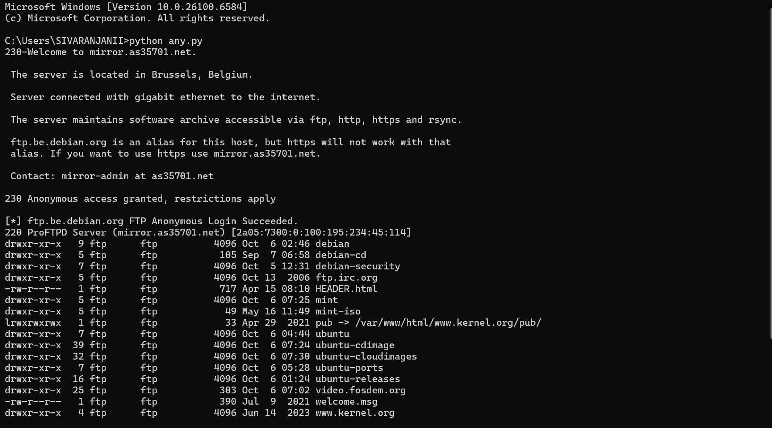

RESULT:
Thus, the anonymous FTP scanner has been built using Ftplib module successfully.

